University of Plymouth

2x16 LCD and H-Bridge Module

Assembly Instructions

James Rogers

[james.rogers@plymouth.ac.uk](mailto:james.rogers@plymouth.ac.uk)

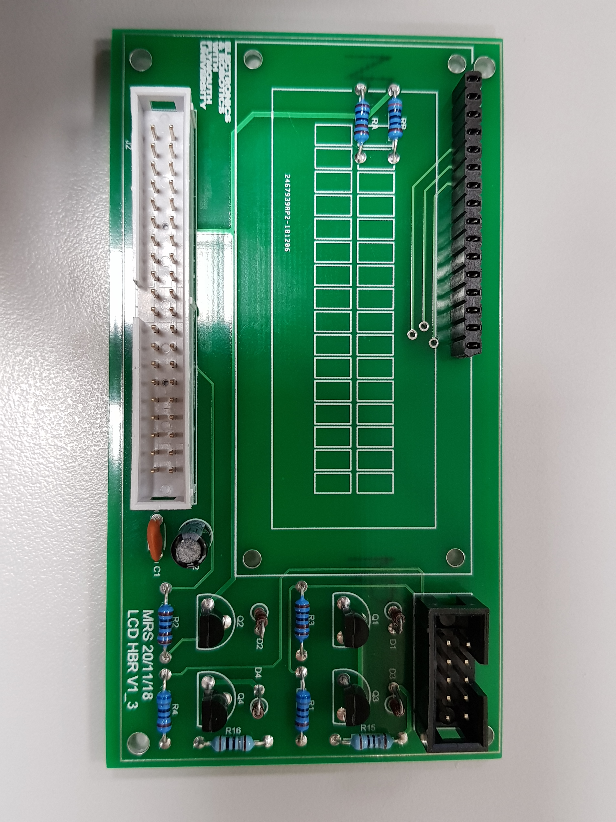

The purpose of this document is to aid in the assembly of the LCD and H-Bridge PCB, which has been designed here at the University of Plymouth to be used with the DE0-NANO FPGA development board.

***You should familiarise yourself with this document and component parts BEFORE assembly.***

**Parts List**

Check that all listed parts (Fig 1) are available in the provided kit

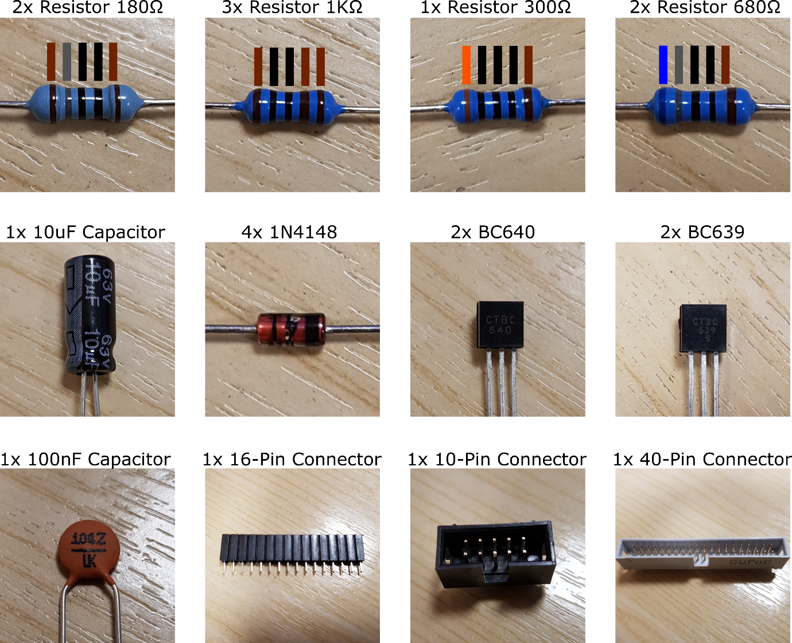

*Fig1: Table of Components*

**Assembly**

The top side of the PCB (Fig 2) has **markings** to indicate the position and orientation of the components. This is the side where the components are mounted.

The bottom side of the PCB (Fig 3) has **no markings**. This is where solder will be applied.

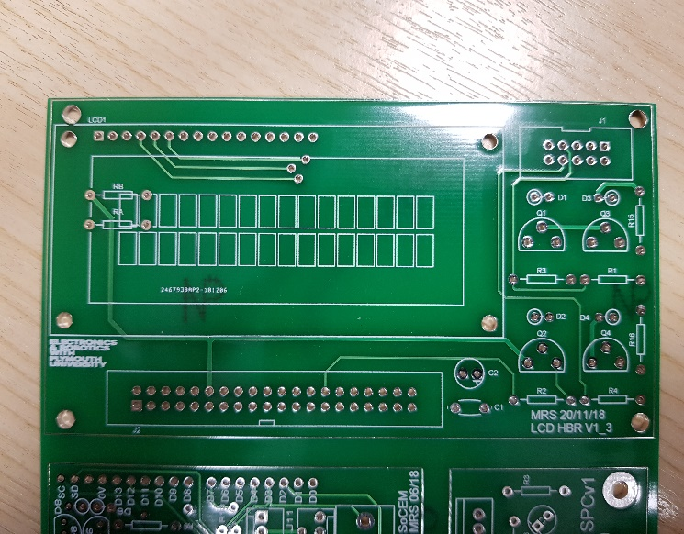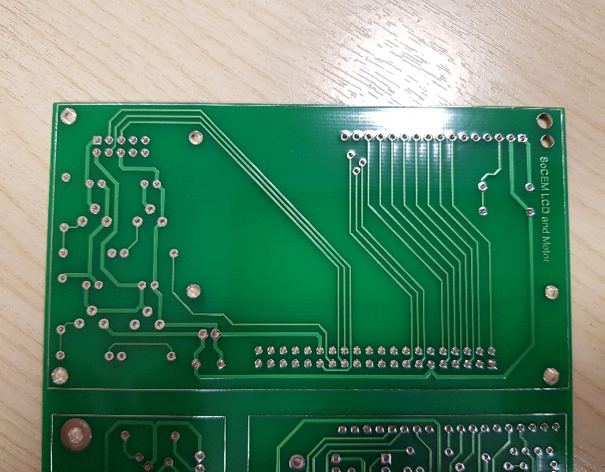

*Fig2: PCB Top Side (Component Side)*

*Fig3: PCB Bottom Side (Solder Side)*

Below is a table of the component codes printed on the PCB, and which part they refer to:

|  |  |
| --- | --- |
| RA, R2, R3 | 1KΩ Resistor |
| RB | 300Ω Resistor |
| R1, R4 | 680Ω Resistor |
| R15, R16 | 180Ω Resistor |
| D1, D2, D3, D4 | 1N4148 |
| Q1, Q2 | BC639 |
| Q3, Q4 | BC640 |
| C1 | 100nF Capacitor |
| C2 | 10uF Capacitor |
| J1 | 10-Pin Connector |
| J2 | 40-Pin Connector |
| LCD1 | 16-Pin Connector |

PCBs are usually assembled in order of height, so that components are pressed flat against the PCB by the work surface as they are soldered.

Resistors

First take the three 1KΩ resistors, and use needle nosed pliers to bend the leads at a 90-degree angle. Hold the lead close to the component body and bend away from the pliers (Fig 4). This is to protect the component body from damage and creates a clean bend.

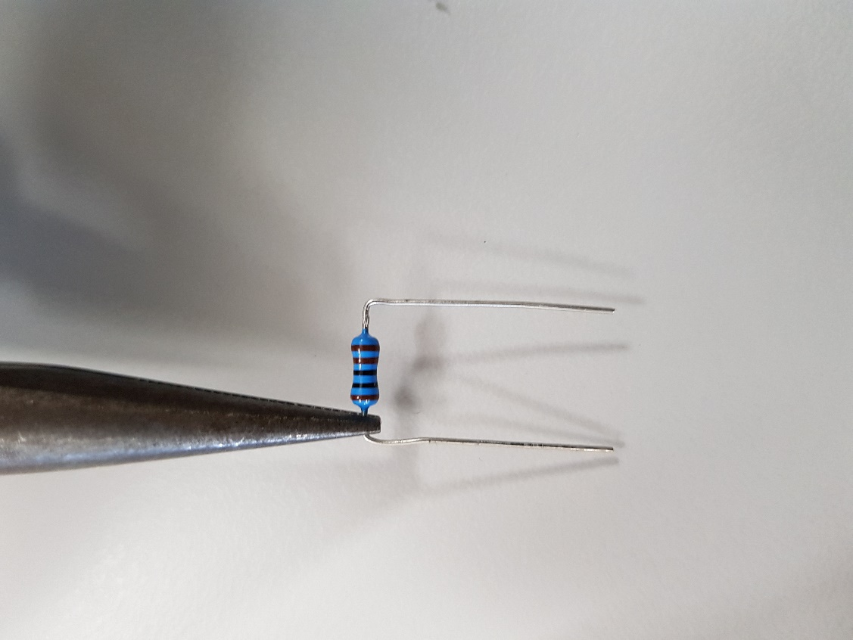

*Fig4: Bending Resistor Leads*

Place the first 1KΩ resistor onto the PCB, threading the leads through the holes marked RA. Assuring the component is flat against the PCB, spread the leads on the solder side of the circuit (Fig 5). This will affix the resistor to the PCB so that it can be soldered.

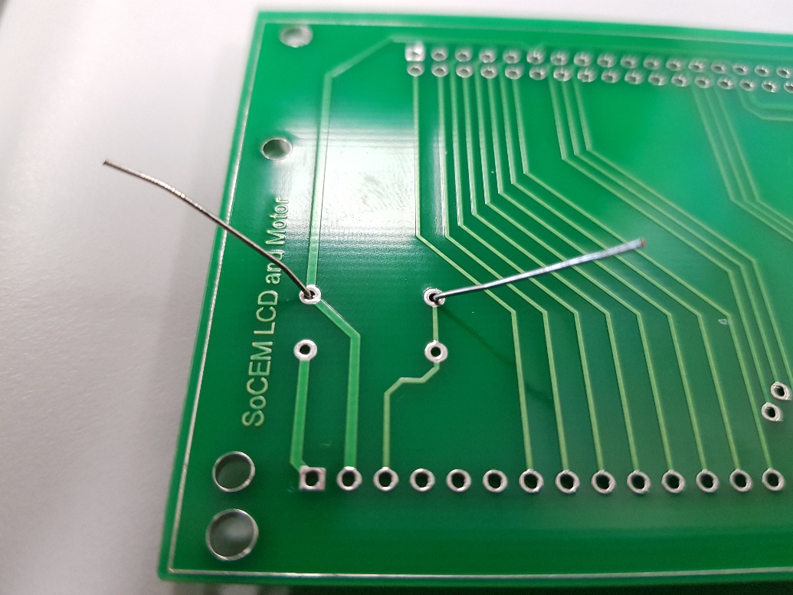

*Fig5: Affixing The Resistor to The PCB*

Next apply solder and crop component leads, so that it resembles Fig6.

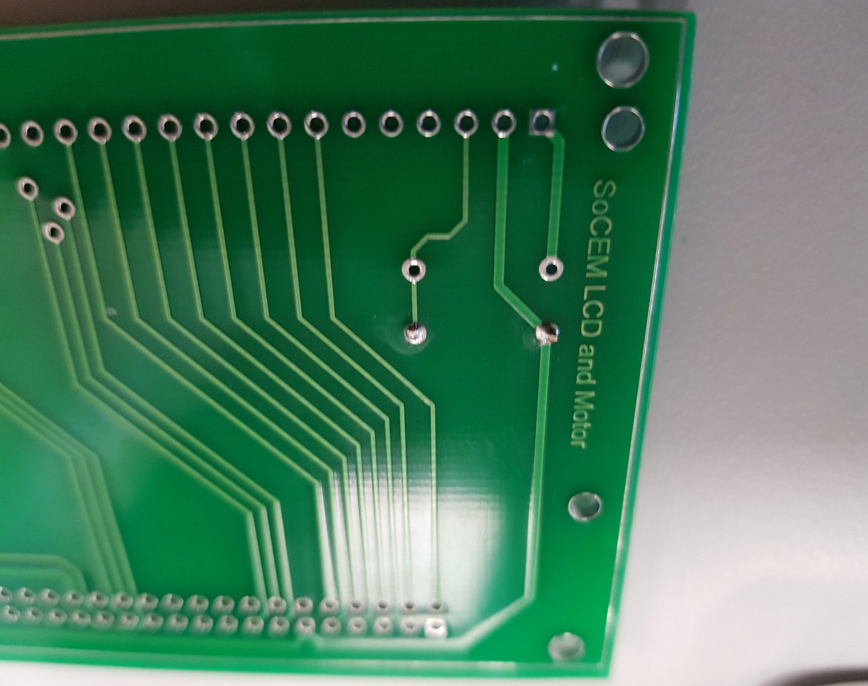

*Fig6: Soldering the Resistor*

Copy this process for the remaining resistors, using the chart below to select the correct values:

|  |  |  |
| --- | --- | --- |
| PCB Code | Component Value | Band Colour |
| RA, R2, R3 | 1KΩ | ■■■■■ |
| RB | 300Ω | ■■■■■ |
| R1, R4 | 680Ω | ■■■■■ |
| R15, R16 | 180Ω | ■■■■■ |

The PCB should look like Fig 7 when all the resistors have been soldered.

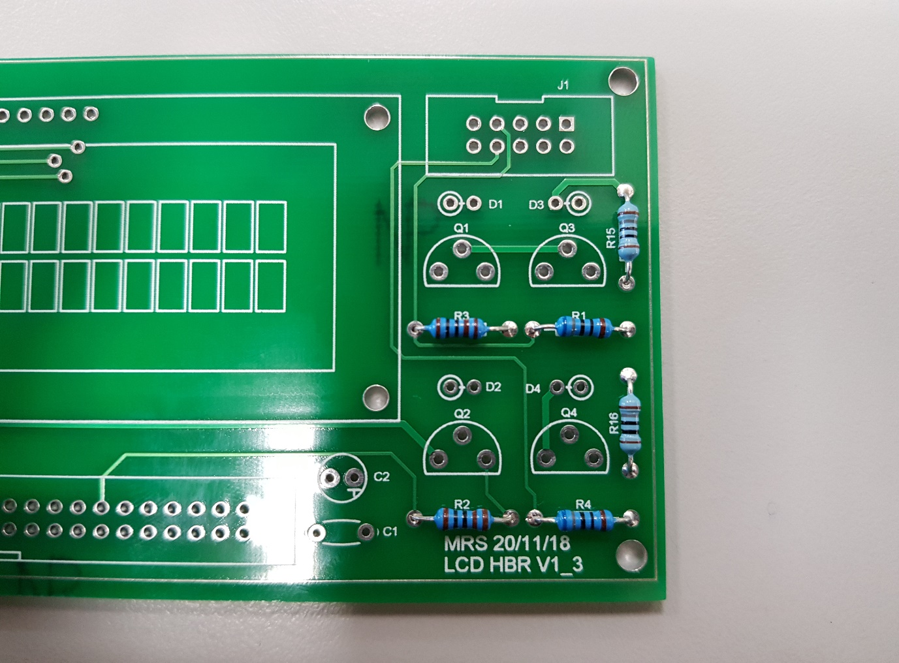

*Fig7: Soldering the Rest of the Resistors*

Diodes

Use pliers to bend one of the leads around 180 degrees (Fig 8). This lead is the one at the **black banded** end of the diode. **Please note that the body of the 1N4148 diode is made from glass, and damage will result in sharp shards.**

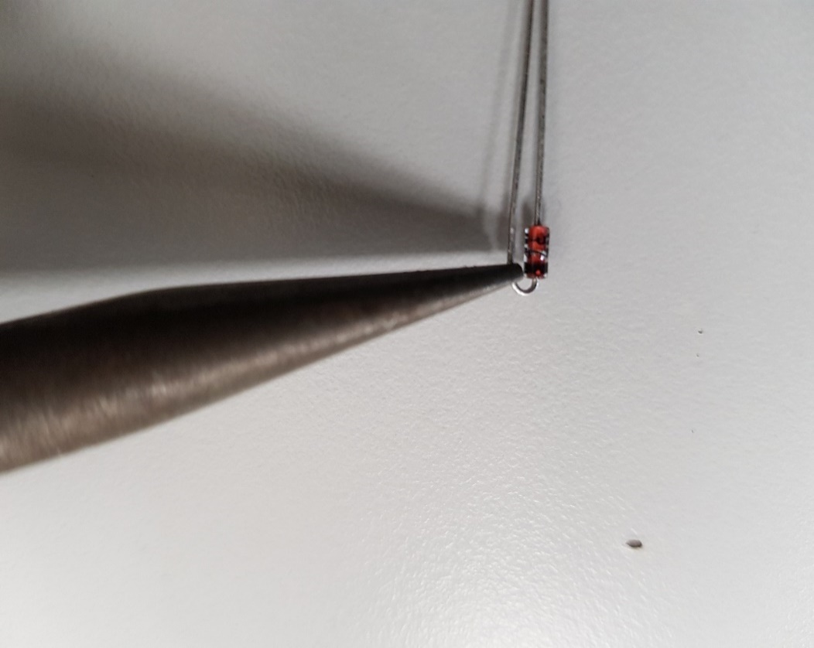

*Fig8: Bending Diode Leads*

Place the diode onto the PCB, **with the body of the component against the hole marked with a white circle, and the bent lead through the unmarked hole (Fig 9).**

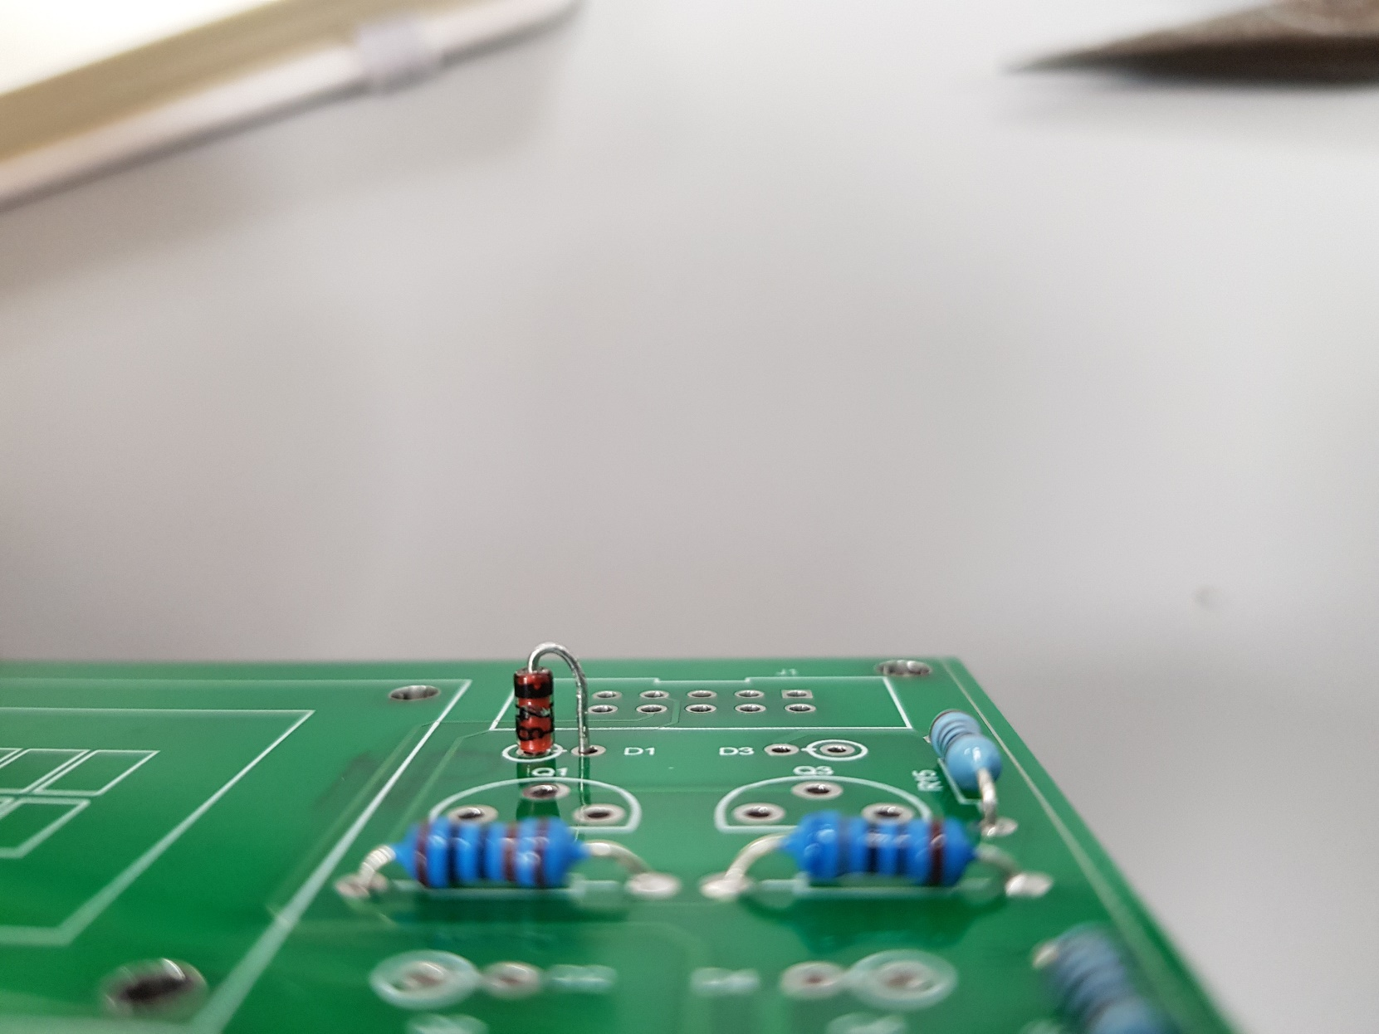

*Fig9: Diode PCB Placement*

Bend the leads on the solder side of the PCB to affix it to the board, then solder and crop the leads. D1, D2, D3, and D4 all use the 1N4148, so repeat this process for the remaining diodes (Fig 10). **Pay attention to the polarity of the diode, and the orientation when it’s on the PCB**

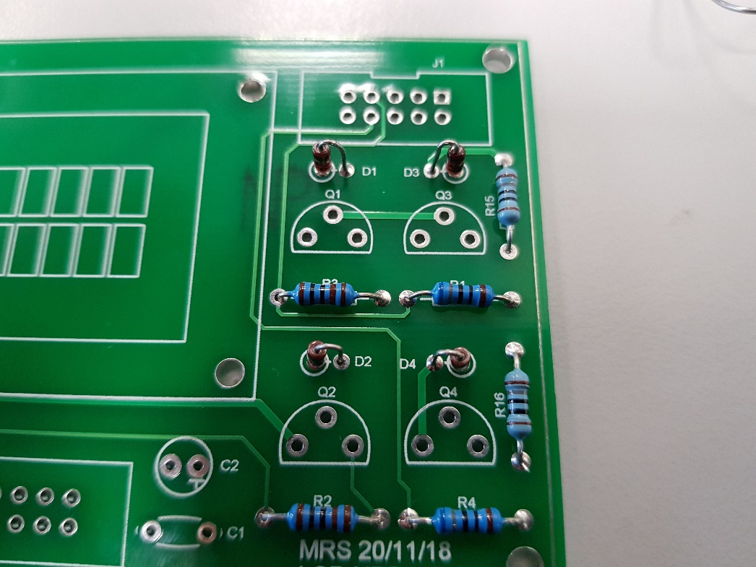

*Fig10: All the Diodes Soldered*

Capacitors

Solder the 100nF capacitor at the position marked C1 (Fig 11). This capacitor is ceramic and is not sensitive to polarity.

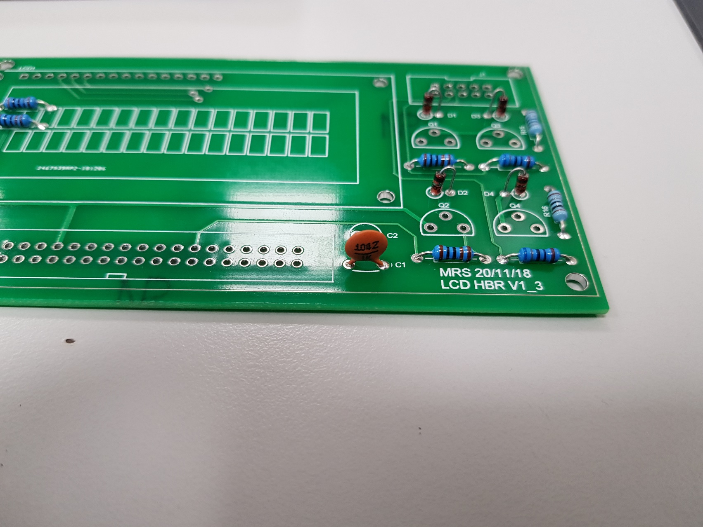

*Fig11: 100nF Capacitor Soldered onto the PCB*

Next identify the 10uF Capacitor, which is electrolytic, and place it on the PCB at the location position marked C2. **Note that this type of capacitor is sensitive to polarity, double check this before soldering (Fig 12).** The long lead of the capacitor is to thread through the hole marked with a plus symbol.

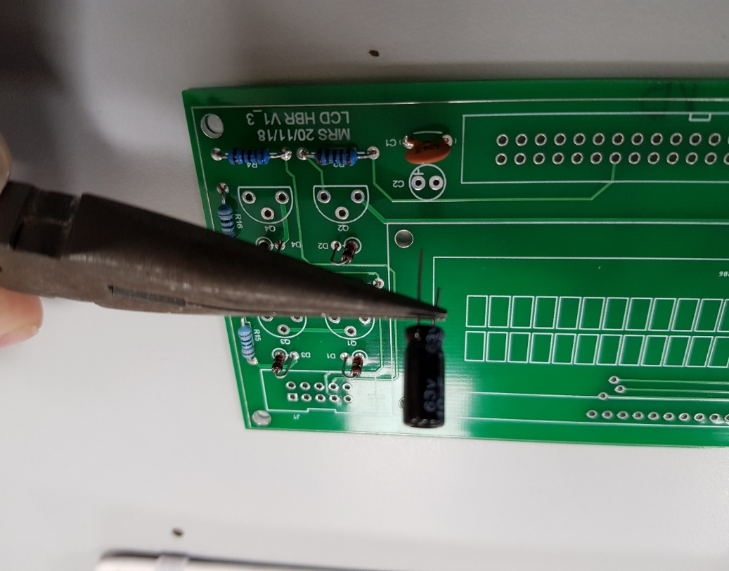

*Fig12: Electrolytic Capacitor Polarity*

Transistors

Take a BC639 transistor (which can be identified by the code engraved on its flat side) and slightly spread its leads (Fig 13).

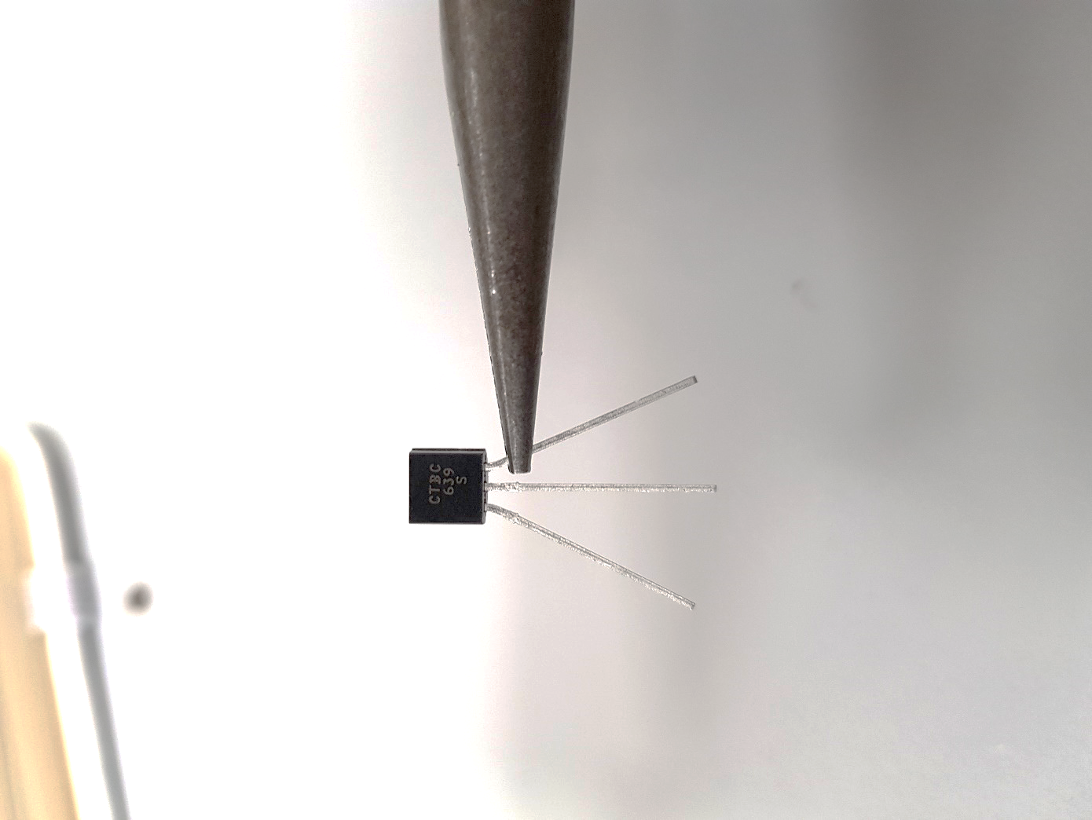

*Fig13: BC639 Transistor with Leads Bent and Code Visible*

Place it onto the PCB at code Q1 and **assure it’s orientated correctly as indicated by the markings on the board (Fig 14).** Spread the leads on the solder side of the PCB to affix the component to the board, then solder and crop the leads.

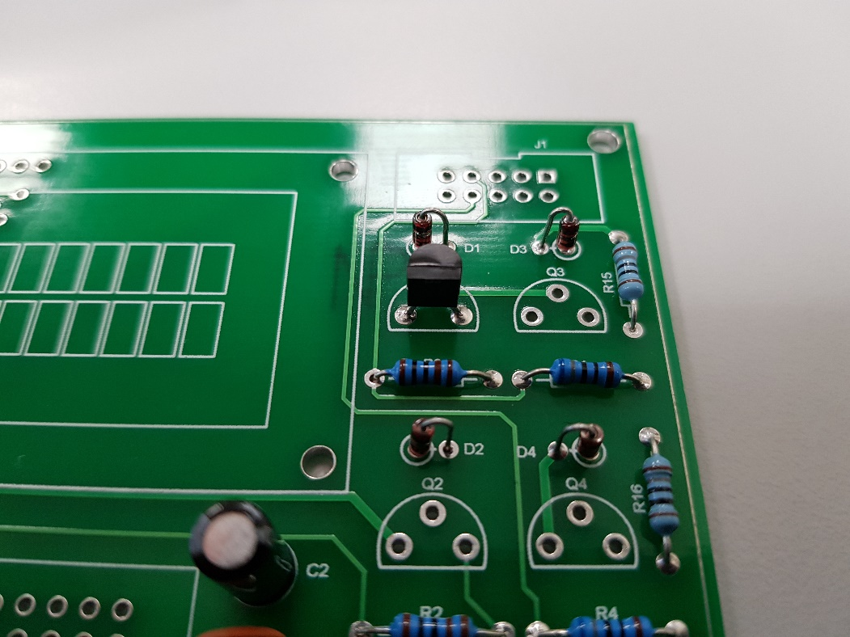

*Fig14: BC639 Transistor Correctly Soldered in Place*

Repeat this process for the remaining transistors, using the table below to select the correct the component. **Double check the transistor codes before soldering.**

|  |  |
| --- | --- |
| PCB Code | Transistor Code |
| Q1, Q2 | BC639 |
| Q3, Q4 | BC640 |

Connectors

Select the 40-pin connector, and **orient it so that the notch aligns with the marking on the PCB (Fig 15).**

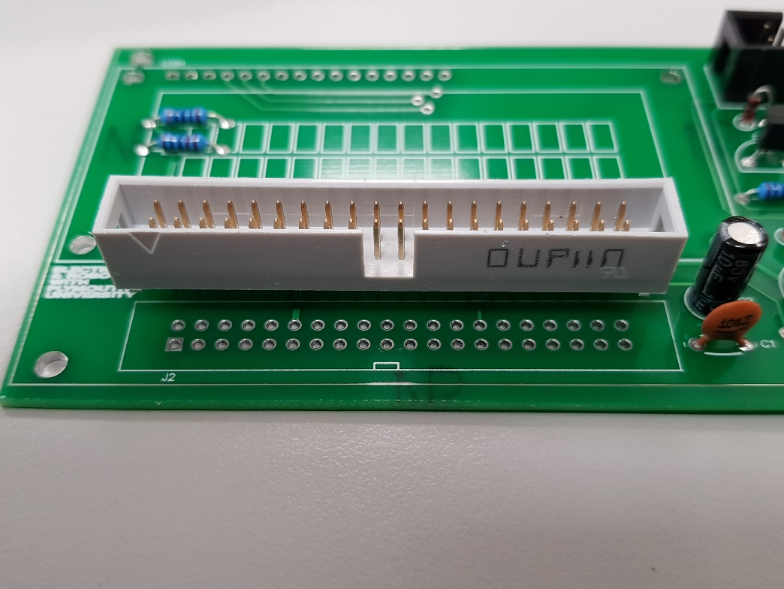

*Fig15: 40-pin Connector Aligned correctly*

Place onto the PCB and **solder only two pins at opposite ends of the connector (Fig 16)**. This is to allow you to reseat the connector so that it sits flat on the board.

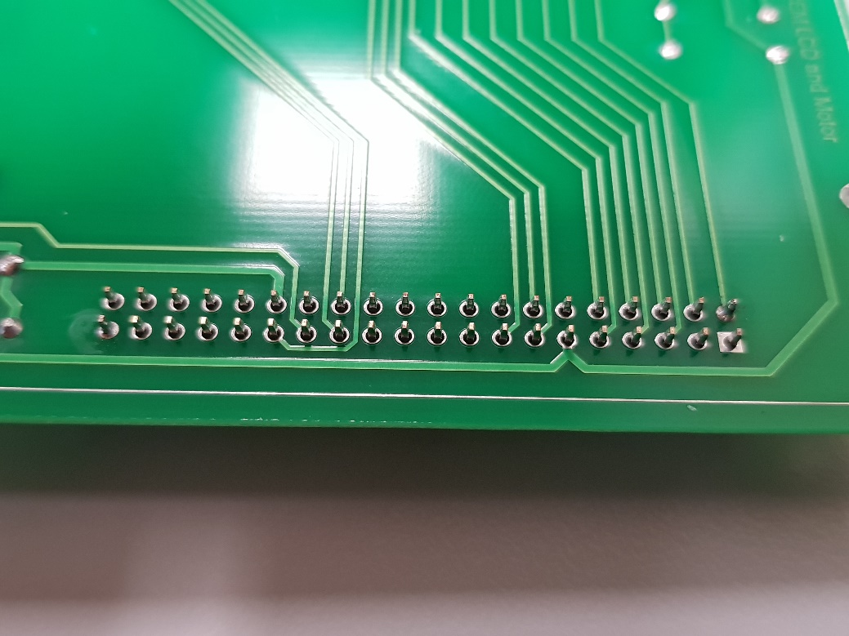

*Fig16: 40-pin Connector Soldered onto the PCB via Two Pins*

If the connector does not sit flat on the PCB, reheat one of the two soldered pins and press the component down so that it does. Once the connector is well seated (Fig 17), solder the remaining pins.

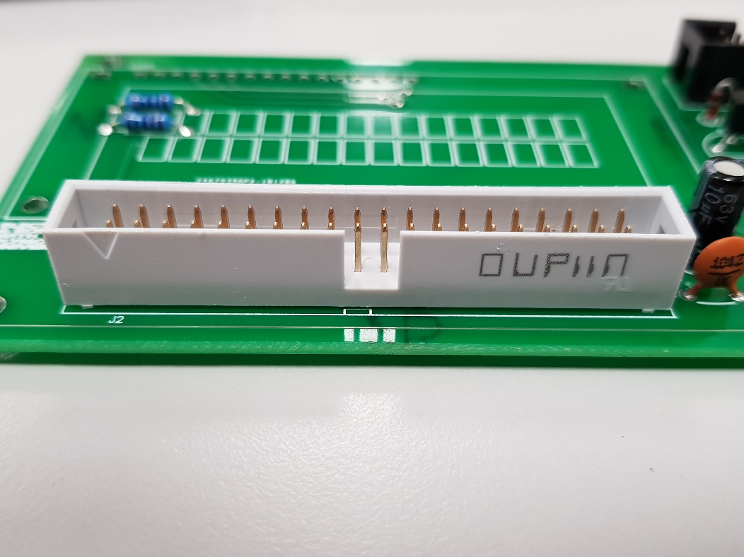

*Fig17: 40-pin Connector Soldered onto the PCB*

Repeat this process for the 10-pin connector and the 16-pin connector to finish the PCB (Fig 18). **The 10-pin connector also has a notch so make sure it is oriented to align with the PCB markings.**

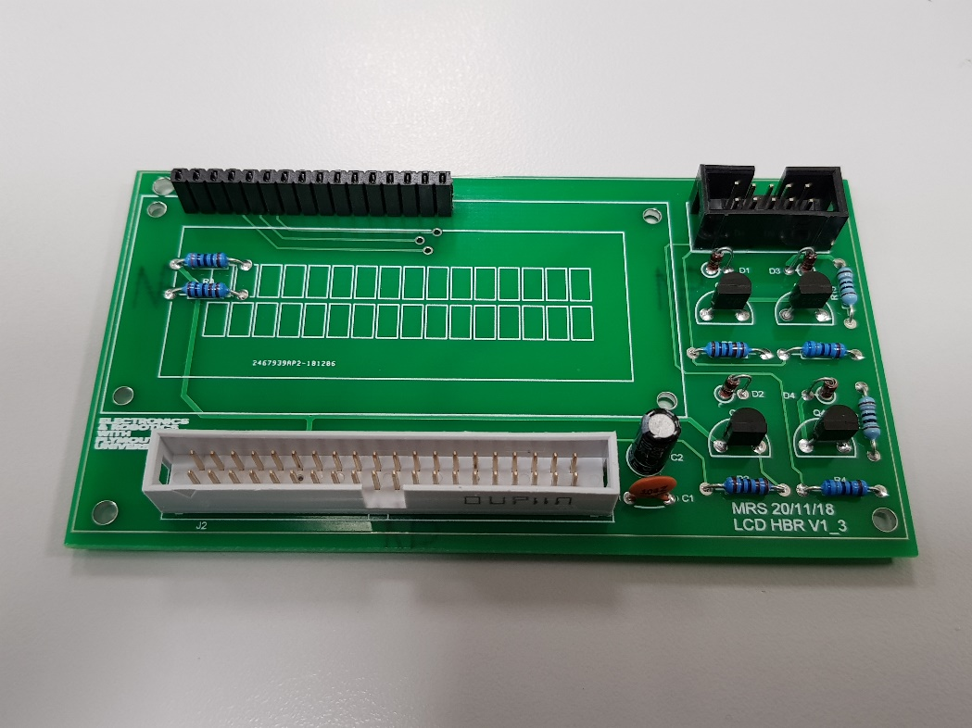

*Fig18: Finished PCB*

***STOP***

**Double check your work and ask a member of staff to confirm assembly is correct before testing and connecting to the DE0-NANO FPGA development board.**

**Molex Connectors**

Select small multicore wire and wire stripping tools (Fig 19). **Use the 24swg hole.**

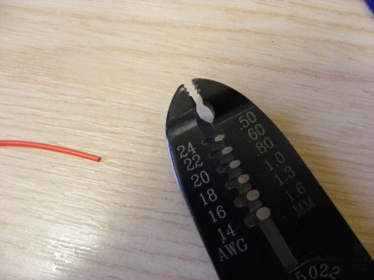

*Fig19: Close up of the Wire Stripping Tool and Wire*

Twist and cut the exposed wire to 4mm approximately (Fig 20).

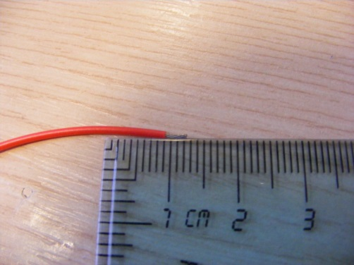

*Fig20: Wire Stripped and Twisted*

Check the fit in the crimp connector. **Assure the wire insulation extends into the first metal tabs of the connector, and the exposed wire sits within the second metal tabs (Fig 21).**

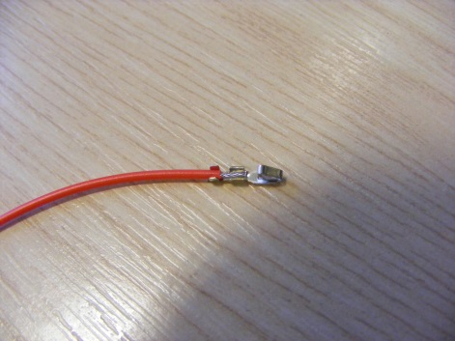

*Fig21: Crimp Test Fit*

Place crimp and wire into the tool and squeeze closed (Fig 22)

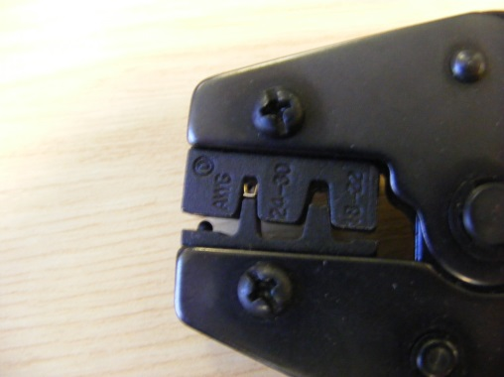

*Fig22: Crimping the Wire*

The crimped wire should appear as Fig 23.

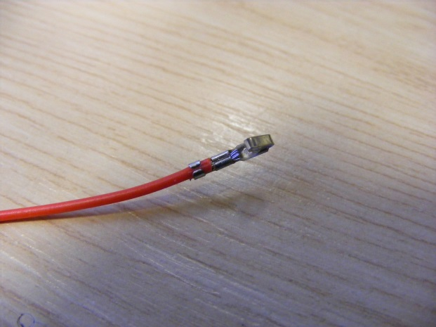

*Fig23: Crimped Wire*

Now place the crimp connector into the housing. Carefully slide it in so that the metal clip protrudes into the window of the Molex connector shown below (Fig 24). **Note that the connector shown is a 3-way connector, but this will vary on the connector you are assembling.**

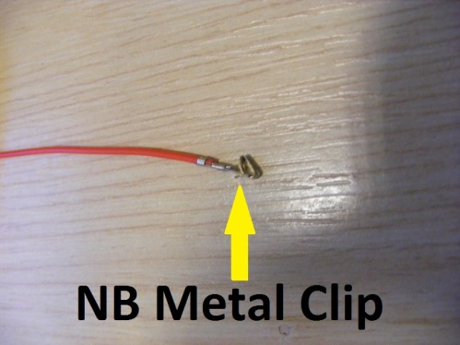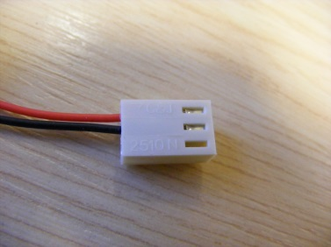

*Fig24: Aligning the Metal Tab with The Molex Connector*

**Ribbon Cable**

The cable described in these instructions is to connect the DE0-NANO FPGA to the Nucleo f429zi.

Cut a length of 40-way ribbon cable approximately 150mm long with sharp scissors. With a pen, **mark two cut lines about 30mm from one end. Starting with the red cable on the left, mark 4 wires, leave 14 wires, then mark the remaining 22 wires (Fig 25).**

**Double check and recount these cut lines again BEFORE cutting**

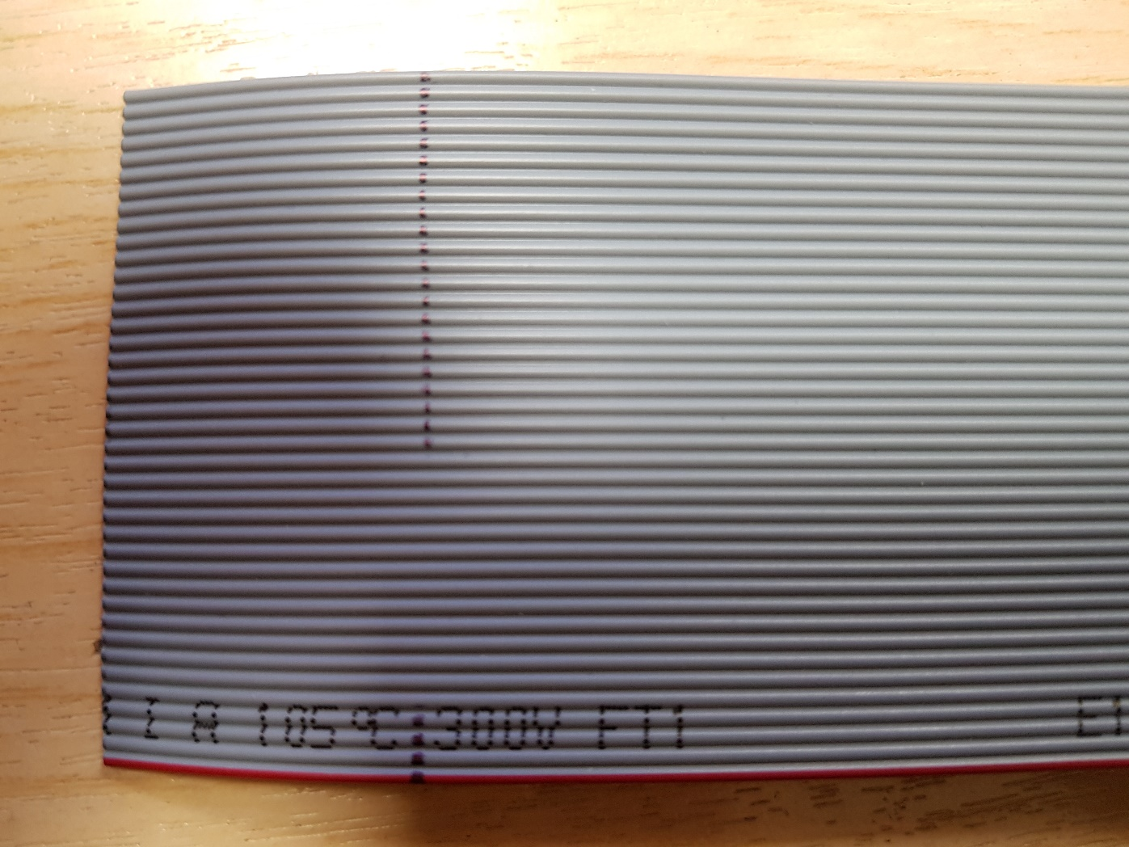

*Fig25: 40-way Ribbon Cable with Marked Cut Lines*

Carefully cut along the marked wires, using the back of the scissors to slowly sever a wire at a time (Fig 26). **Take extra care with the last wires on each cut.**

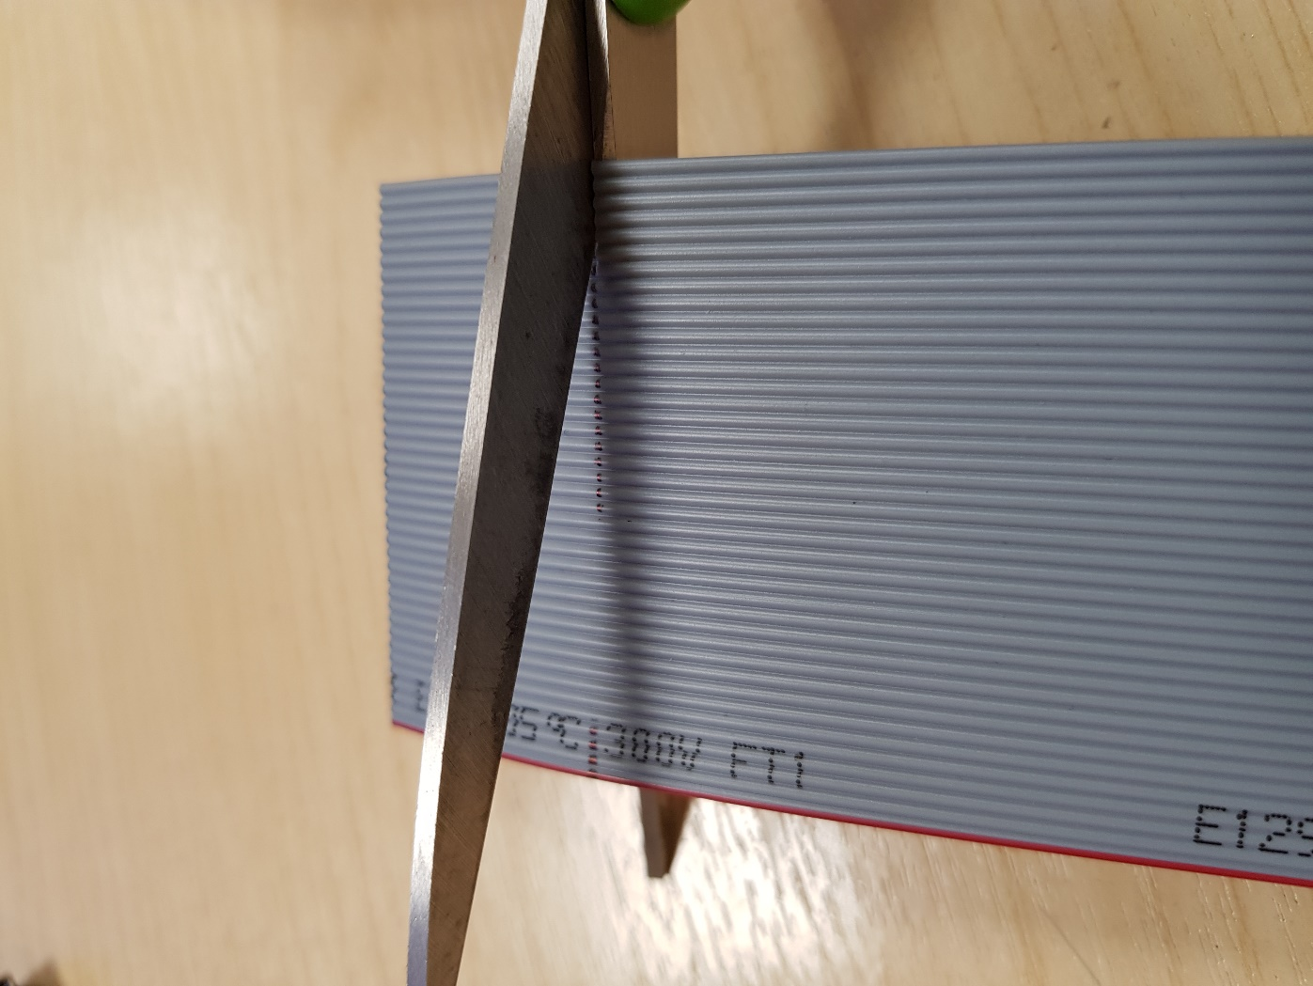

*Fig26: Cutting the Marked Wires*

Peal the cut wires back **away from the end of the ribbon cable** (Fig 27), being careful not to apply too much force on the 14 remaining wires. Continue until the cut wires are completely removed.

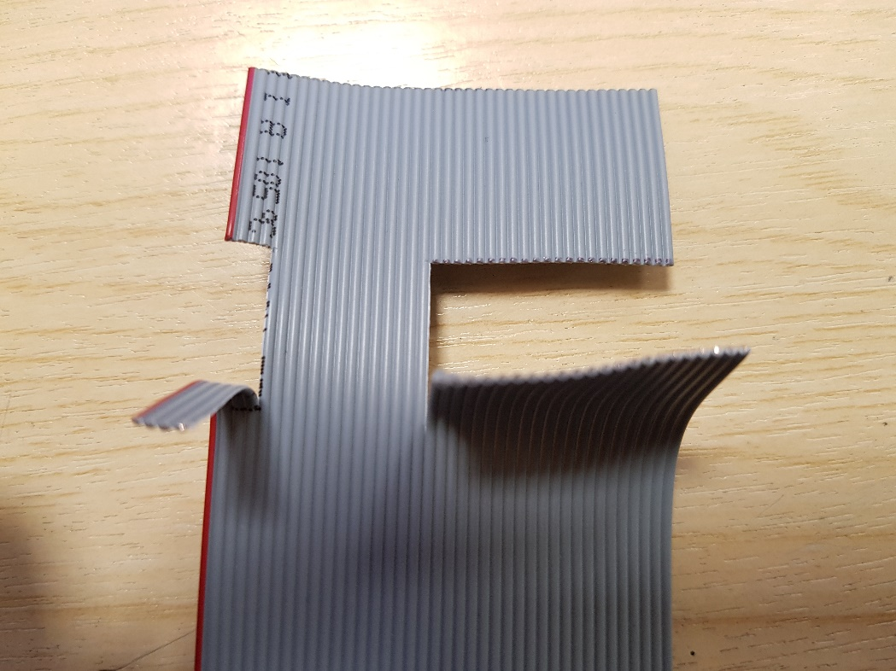

*Fig27: Pealing away the Cut Wires*

The ribbon cable connector comes in three parts, designated A, B, and C (Fig 28). Part A has a bed of sharp metal groves. Part B pushes the ribbon cable down onto these grooves, which cuts though the insulation and makes contact with the bare wires. Part C holds onto the cable so that no stress is put onto the electrical connections when pulled from a socket.

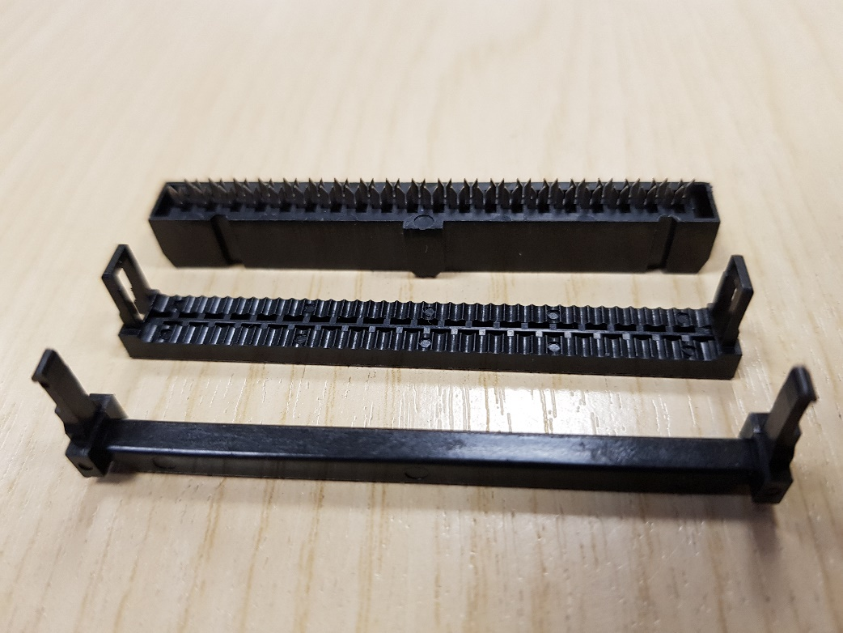

**A:**

**B:**

**C:**

*Fig28: The Three Parts of a Ribbon Cable Connector*

Insert part B into part A (Fig 29), **but not all the way.** Assure there is a gap through which you can insert the ribbon cable.

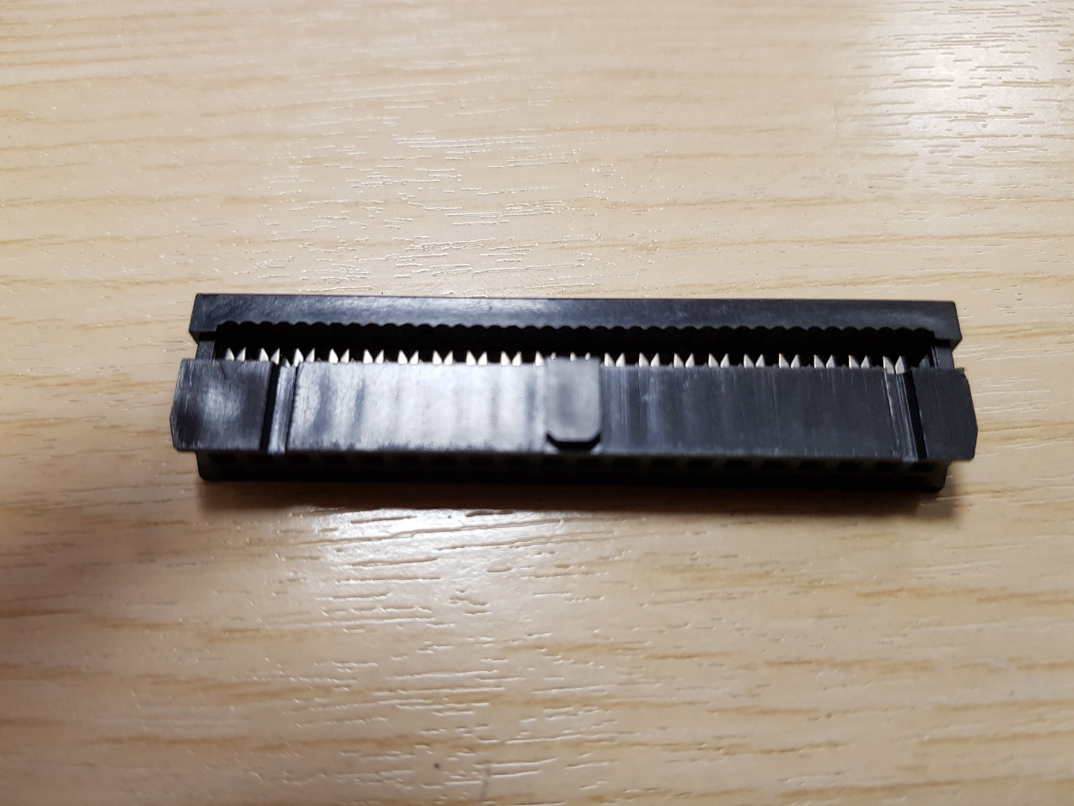

*Fig29: Connector Part A and B*

Place the 40-way end of the cable into the open slot of the connector. The side in which the cable is inserted is **the notched side with the red cable on the left (Fig 30).**

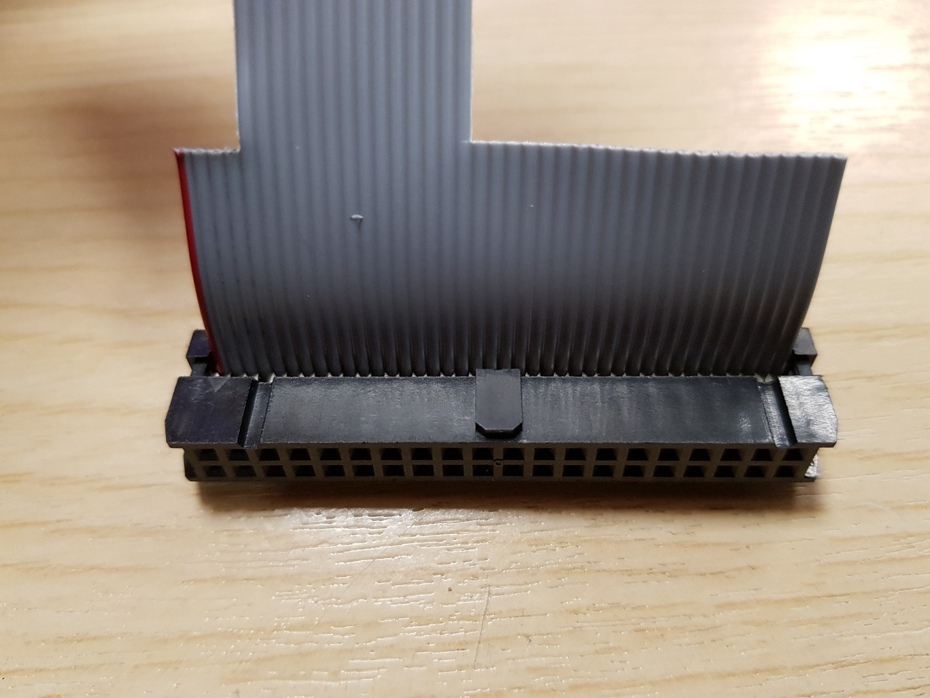

*Fig30: Ribbon Cable Inserted into the Open Connector*

Place the connector and cable into the removable support block from the ribbon crimp tool. Check the orientation of the cable and assure that it is perpendicular to the connector.

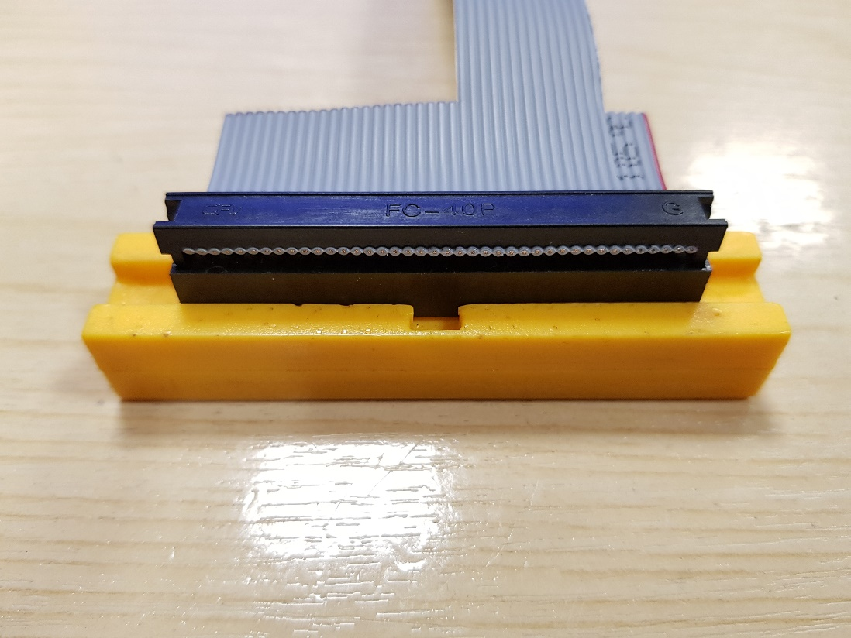

*Fig31: Ribbon Connector Placed into the Crimp Support*

Place the crimp support into the crimp tool, and **do a final check that everything is oriented correctly (Fig 32).** Squeeze firmly on the tool until parts A and B fully lock together.

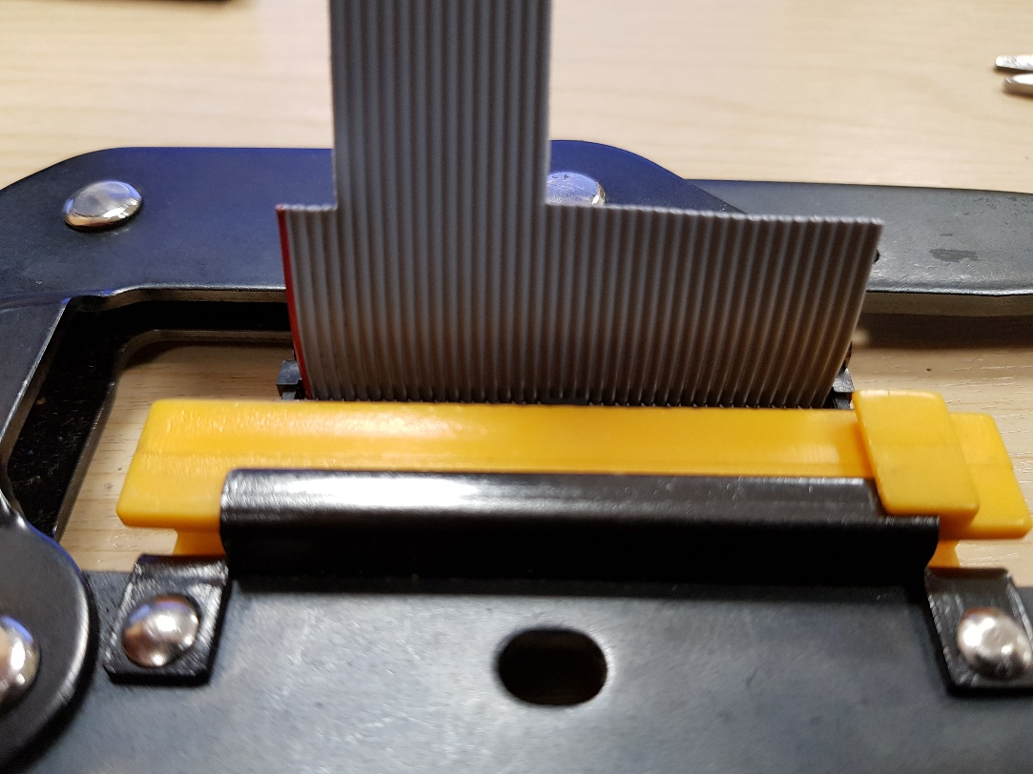

*Fig32: Ribbon Connector inside the Crimping Tool*

Now that the connector is crimped to the ribbon cable, fold the cable back over the connector as shown in Fig 33.

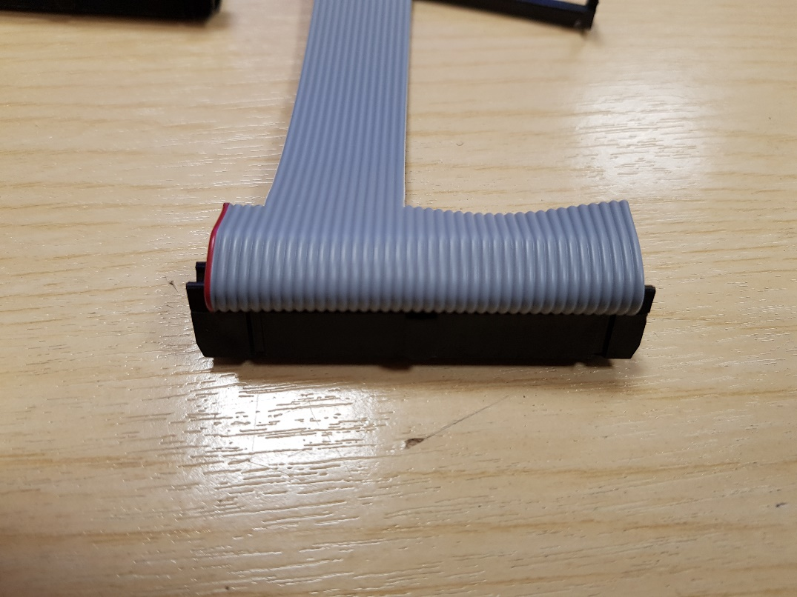

*Fig33: Folding the Cable back over the Connector*

Finally attach part C over the cable to fasten it down (Fig 34).

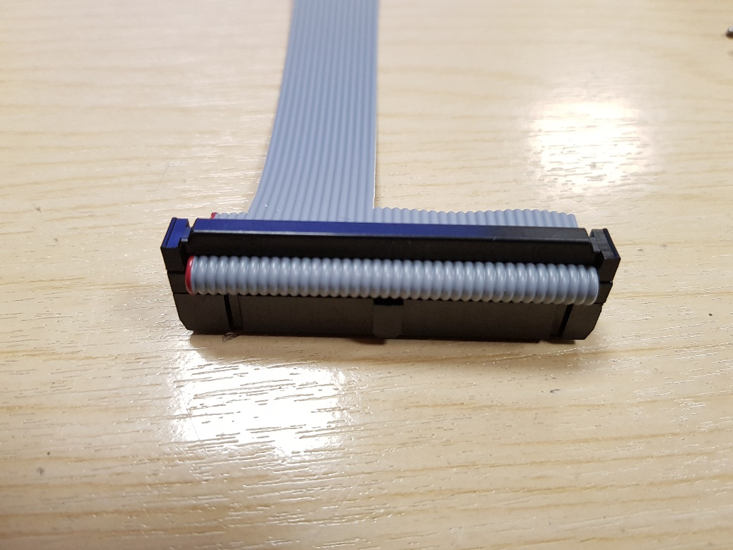

*Fig34: Completed 40-way Ribbon Connector*

This process is to be repeated for the 14-way Connector. However, **pay very close attention to the orientation of this connector relative to the 40-way one (Fig 35).** Note how it is upside down compared to the 40-way connector, as it will have to be folded over when attaching the 14-way cable fastener.

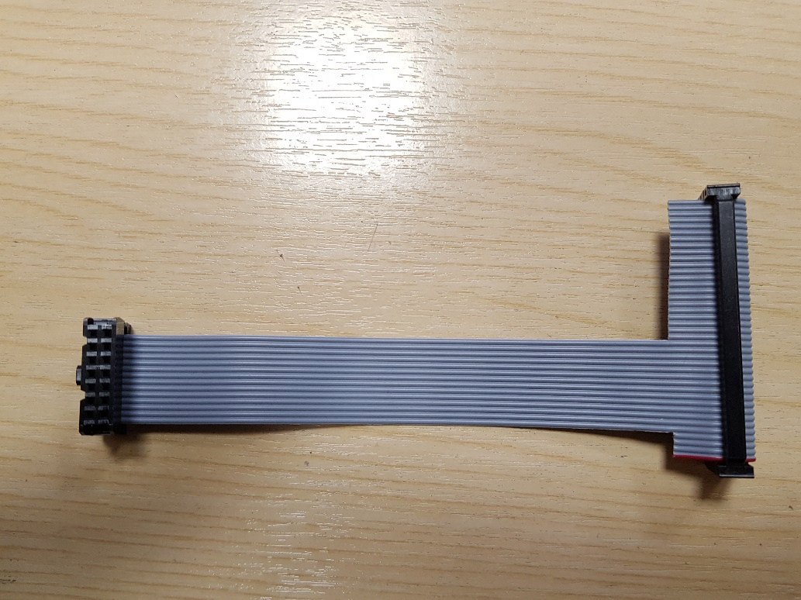

*Fig35: How the 14-way Connector is Oriented to the 40-way Connector*

Once crimped, fold over the connector as shown in Fig 36.

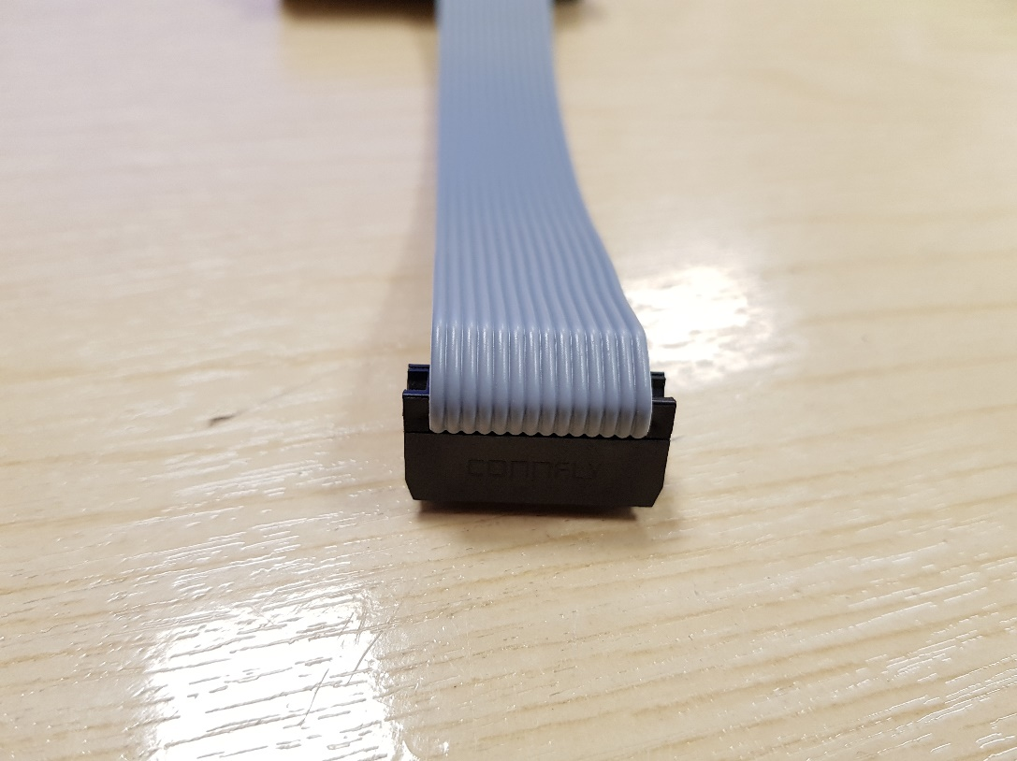

*Fig36: 14-way Connector Crimped and Folded over*

Finally attach the 14-way cable fastener and the cable is complete (Fig 37).

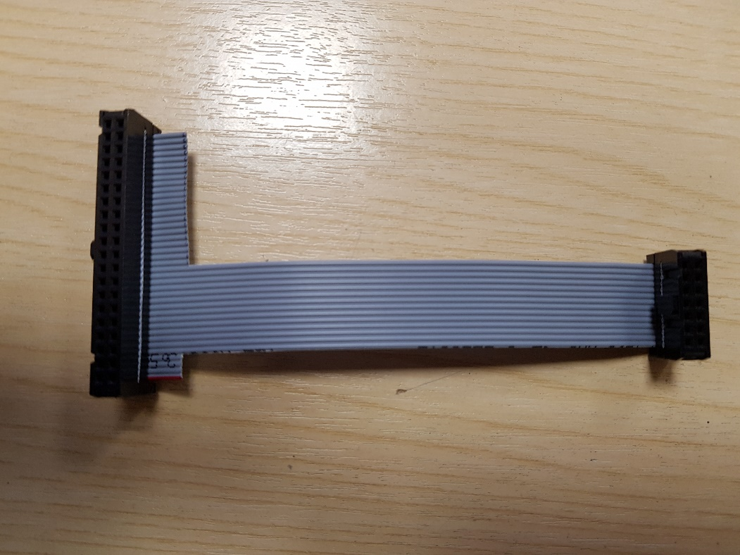

*Fig37: Completed Cable*

**Double check your work and ask a member of staff to confirm the cable is correct before testing and connecting to the DE0-NANO FPGA or the Nucleo Development Board.**